
Alice Ingham

Statutory Requirements  The national curriculum for design and technology aims to ensure that all pupils:  - Develop the creative, technical and practical expertise needed to perform everyday tasks confidently and to participate successfully in an increasingly technological world  - Build and apply a repertoire of knowledge, understanding and skills in order to design and make high-quality prototypes and products for a wide range of users  - Critique, evaluate and test their ideas and products and the work of others Understand and apply the principles of nutrition and learn how to cook. | KS1 | LKS2 | UKS2
 | Through a variety of creative and practical activities, pupils should be taught the knowledge, understanding and skills needed to engage in an iterative process of designing and making. They should work in a range of relevant contexts [for example, the home and school, gardens and playgrounds, the local community, industry and the wider environment]. When designing and making, pupils should be taught to:  Design  - Design purposeful, functional, appealing products for themselves and other users  based on design criteria  - Generate, develop, model and communicate their ideas through talking, drawing, templates, mock-ups and, where appropriate, information and communication technology  Make  - Select from and use a range of tools and equipment to perform practical tasks [for example, cutting, shaping, joining and finishing]  - Select from and use a wide range of materials and components, including construction materials, textiles and ingredients, according to their characteristics  Evaluate  - Explore and evaluate a range of existing products  - Evaluate their ideas and products against design criteria  Technical knowledge  - Build structures, exploring how they can be made stronger, stiffer and more stable  - Explore and use mechanisms [for example, levers, sliders, wheels and axles], in their products. | Through a variety of creative and practical activities, pupils should be taught the knowledge, understanding and skills needed to engage in an iterative process of designing and making. They should work in a range of relevant contexts [for example, the home, school, leisure, culture, enterprise, industry and the wider environment]. When designing and making, pupils should be taught to:  Design  - Use research and develop design criteria to inform the design of innovative, functional, appealing products that are fit for purpose, aimed at particular individuals or groups  - Generate, develop, model and communicate their ideas through discussion, annotated sketches, cross-sectional and exploded diagrams, prototypes, pattern pieces and computer-aided design  Make  - Select from and use a wider range of tools and equipment to perform practical tasks [for example, cutting, shaping, joining and finishing], accurately  - Select from and use a wider range of materials and components, including construction materials, textiles and ingredients, according to their functional properties and aesthetic qualities  Evaluate  - Investigate and analyse a range of existing products  - Evaluate their ideas and products against their own design criteria and consider the views of others to improve their work  - Understand how key events and individuals in design and technology have helped shape the world  Technical knowledge  - Apply their understanding of how to strengthen, stiffen and reinforce more complex structures  - Understand and use mechanical systems in their products [for example, gears, pulleys, cams, levers and linkages]  - Understand and use electrical systems in their products [for example, series circuits incorporating switches, bulbs, buzzers and motors]  - Apply their understanding of computing to program, monitor and control their products.

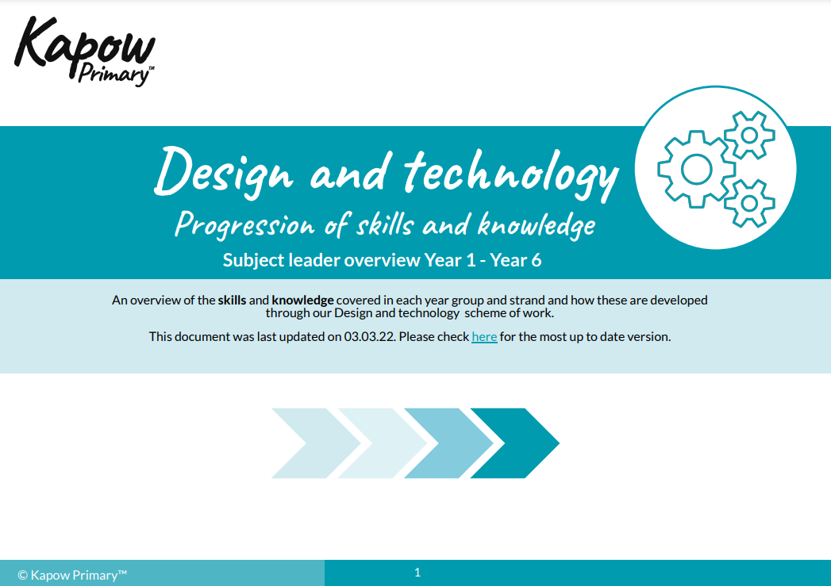
Document from https://www.kapowprimary.com/subjects/design-technology/
